AD IMAGE SPECIFICATIONS
Advertising Creative for Family Dollar Must Meet the Following Specs:
Source Format | 1-bit Black & White BMP File
Image size or Max File Size | 39 kb
Color mode | Monochrome (Black & White – No Grayscale)
Width and Height | Maximum: 507 W x 509 H pixels (approx. 2.5” x 2.5”)
Resolution | 203 dpi
Bit Depth | 1-bit
Suggested Manufacturer/Expiration/Legal Font and Font Size | Arial and Verdana; ≤ 6.5 pt (6.5 pt provides best quality at smallest pt size legible)
Coupon Barcode | If using a barcode, Creative Services will insert into artwork under graphic file. Manufacturer must supply data string associated with one of the following barcode types: UPC-A, UPC-E, EAN-8, EAN-13, Code128, Code39

AD SPEC SHEET

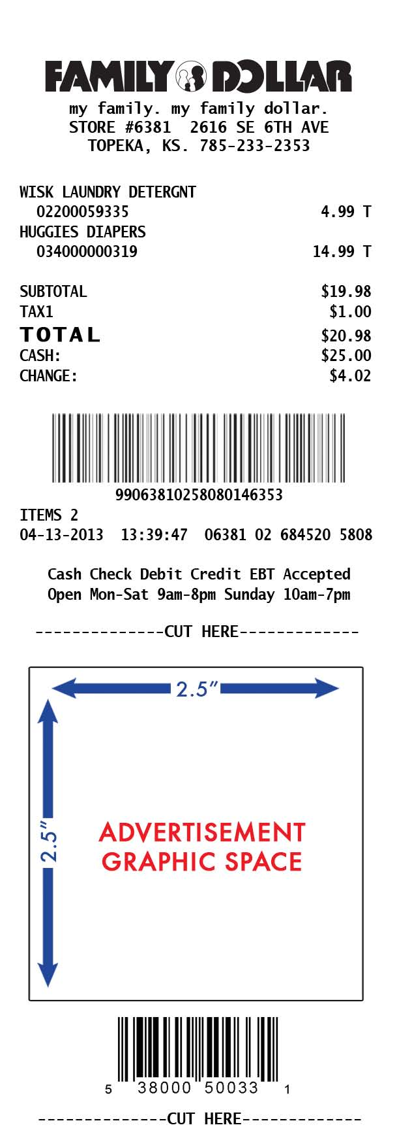
TECHNICAL SPECIFICATIONS

• Ads may not contain any color; do not use grayscale/halftone or dithered images, only black & white 1-bit bitmaps
• Avoid light weight fonts to ensure legibility
• Avoid serif fonts below 7pt
• When using condensed or narrow fonts, increase kerning
• Retailer reserves the right to reject graphics and/or content that does not meet the above specifications. Ads are not final until approved by Family Dollar.

Ads for new campaigns or mid-campaign changes should be submitted for testing and review according to the fourteen day lead time requirement

