Contract for transactional Media Sales (including parcel inserts)
FLAVOR SAMPLING LTD company number – [12125350]
- The contract is made between FLAVOR SAMPLING LTD and Transactional Media Ltd trading as Connections by The Specialist Works, and covers the sale of transactional inserts, being third party and FLAVOR SAMPLING LTD inserts into product despatches.

- The contract shall be deemed to have commenced on 26th January 2021 and will continue until 25th January 2022 subject to earlier termination as provided in clause 10. Thereafter the contract will continue on a rolling basis with not less than 3 months’ written notice by either party.

- Connections by The Specialist Works is exclusively appointed to manage insert sales on behalf of FLAVOR SAMPLING LTD in line with the SOW timelines

- New timelines will be submitted every 12 month period by Connections by The Specialist Works.

- Connections by The Specialist Works will gain copy approval from FLAVOR SAMPLING LTD, and ensure third party messages do not conflict with FLAVOR SAMPLING LTD brand values and are within Advertising Standards Authority guidelines being legal, honest and decent and comply with applicable laws. The insert carrier FLAVOR SAMPLING LTD reserves the right to decline to distribute inserts with certain products or from certain companies (principally but not exclusively where FLAVOR SAMPLING LTD believe the adverts to either be competitive in nature to the core offering, conflicting with FLAVOR SAMPLING LTD brand values, believe the adverts infringe the Advertising Standards Authority guidelines or do not comply with applicable laws).

Connections by The Specialist Works will manage the process to ensure that advertisers comply with the insert format and weight restrictions, as pre-determined by FLAVOR SAMPLING LTD, for the product despatch inserted advertisement or sampling opportunities. FLAVOR SAMPLING LTD will agree with Connections by The Specialist Works of the insert restrictions for carrying inserts within their parcels.

An example of insert slots to form the offers loose in the parcels would be as follows:
6x Loose Slots will be available for third party advertising (4x paid by third parties, 2x trade, with a maximum overall size of A5). In the event of a paid or trade hopper being vacant then a trade or paid for opportunity can be offered as an alternative.

- Connections by The Specialist Works will be entitled to a sales commission on sales revenue they generate from “Gross Insert Revenue Received by Connections by The Specialist Works” (defined as income received by Connections by The Specialist Works from third party insert sales generated by Connections by The Specialist Works, before any deduction of Connections by The Specialist Works commission due, but after deduction of any subsequent refunds/ discounts and exclusive of VAT). Connections by The Specialist Works’ commission will be paid at 30% of Gross Insert Revenue Received by Connections by The Specialist Works each month for third party inserts into product despatches.

- Other fees and charges payable under this contract will be as follows:
- All pack production costs will be paid to Connections by The Specialist Works at a rate of £30 per ‘000 if applicable
- Trade admin fees will be charged for trade inserts and paid for by FLAVOR SAMPLING LTD at a rate of £5.00 per thousand.

Connections by The Specialist Works will set prices based on a competitive market rate based on market demand and availability. Connections by The Specialist Works reserve the right to offer additional discounts to new brand trials, high volume or loyal commitment, such discounts will be at the sole discretion of Connections by The Specialist Works down to agreed minimum acceptable NET cost of £25/000. Connections by The Specialist Works will only deviate from these minimum acceptable levels if prior written approval is received from FLAVOR SAMPLING LTD.
Sampling will be only offered with prior agreement from FLAVOR SAMPLING LTD.
- Prior to accepting any confirmed booking from an advertiser direct or through an agency Connections by The Specialist Works will ensure that their credit insurance adequately covers the gross value of the booking (evidence to be provided if requested by FLAVOR SAMPLING LTD). Where this is not possible Connections by The Specialist Works will ensure that full prepayment has cleared Connections by The Specialist Works’s bank 7 days prior to insert delivery.
- Parcel Volumes – will be forecasted for a 12 month period with quarterly reappraisals of forecasts and written confirmation thereof. Advertiser rebates caused through under delivery will be automatically charged against the account. FLAVOR SAMPLING LTD will endeavour to place a pre-agreed quantity of inserts within a specified timeframe (such quantities and timeframes to be agreed between the parties in writing. Changes in volumes to be distributed or other specifications (i.e. acceptable weight / size of third-party inserts) relating to distributions should be notified to Connections by The Specialist Works 90 days prior.
Furthermore, any orders placed prior to such changes should be accepted by FLAVOR SAMPLING LTD. Where changes in volume occur, there will need to be recalculation of net target forecast for the period pro rata to the change. Notification of such changes should be given to Connections by The Specialist Works as soon as possible in advance of the first distribution date wherever reasonably possible.
- In the event of any cancellation caused by FLAVOR SAMPLING LTD to the planned distribution as agreed (unless cancelled in accordance with clause 4 above), FLAVOR SAMPLING LTD will cover any compensation Connections by The Specialist Works need to pay the advertiser/agency up to the value of the cost of the advertisers print, production and delivery cost, plus FLAVOR SAMPLING LTD will compensate Connections by The Specialist Works for the value of the commission lost on the sale, subject in each case to an aggregate cap of £3,000 per applicable affected insert slot in respect of any claims made under this clause unless cancellation is due to circumstances that are reasonably ‘beyond the control’ of FLAVOR SAMPLING LTD in which case such compensation would not be payable by FLAVOR SAMPLING LTD. For clarity in the instance if there is no easily defined liability all parties agree to discuss in good faith and come to an agreement with regard to any compensation on any affected parties.

- FLAVOR SAMPLING LTD shall be entitled to terminate this agreement immediately by serving written notice at Connections by The Specialist Works registered address, should Connections by The Specialist Works fail to pay its debts owed to FLAVOR SAMPLING LTD within the agreed payment due dates unless the payments are delayed due to a dispute. In this instance Connections by The Specialist Works will be given the opportunity to discuss and resolve within a 30 day period.
A termination under this provision will release FLAVOR SAMPLING LTD from liability from clause 8 (with exception of historical outstanding liabilities already recorded).

- For the avoidance of doubt, this agreement and the services Connections by The Specialist Works provide to FLAVOR SAMPLING LTD shall remain confidential and Connections by The Specialist Works shall not use FLAVOR SAMPLING LTD images, designs or trademarks for any purpose), including promotion or marketing, without FLAVOR SAMPLING LTD prior written consent (other than confidential enablement of ad sales to third party advertisers as outlined in this agreement).

- All invoices under this agreement shall be submitted by each party to the other on a monthly basis and as soon as practicable after the end of each calendar month and shall be payable by each party within 30 days from receipt of invoice.

This agreement is governed by English Law. Any changes to this agreement must be in writing and agreed by both parties.

For FLAVOR SAMPLING LTD trading as FLAVOR SAMPLING LTD |  | For Transactional Media Ltd – t/a Connections by The Specialist Works
Signed |  | Signed | 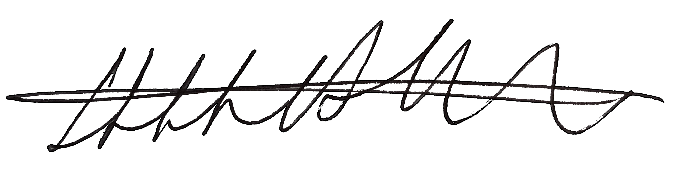
Name |  | Name | Huw Whitethread
Position |  | Position | Client Director
Date |  | Date | 26.01.2021

