**THG ICONS – Goods In Process**

**Booking-In Process**

* Please fill in the attached booking form with all the relevant details (incl. THG Purchase Order Number, THG SKU, Description, Number of Units, Number of Pallets)
* Please send your booking request to the below email addresses to arrange a booking **48hrs** prior to delivery:
  + THGBookingM2@thehutgroup.com and Suzanne.hoole:thehutgroup.com
* A copy of this booking form **MUST** be sent with the delivery
* All fields highlighted with blue on the below picture are mandatory (booking form attached for your reference as well)
* Deliveries that aren’t pre-booked before arrival **will be refused**

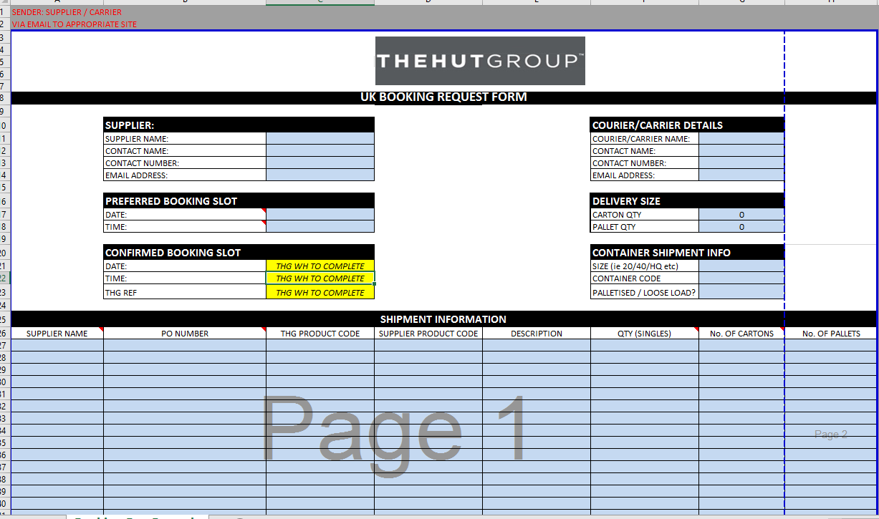

* The booking is not confirmed until you have received a confirmation back from our warehouse which details an alphanumeric number which you must provide to the carrier / driver making your delivery.
* THG ICON confirms a booking reference – example of this number (reference) is *90-200916-001.*
* All the boxes/pallets have to be labelled with the given booking reference with a QR code.
* Drivers must quote the booking reference to gain access to the site on the day of delivery.

**Packaging**

All items handed over to a carrier must be packaged according to transport-safety. All goods are to be delivered on undamaged Euro pallets. In any case, the supplier has to ensure through the use of appropriate tools and packaging that the goods reach their destination in good condition.

* Pallet shipments
  + Only Euro Pallets are accepted
  + Maximum Height including Pallet is 1.8 metres.
  + Maximum Weight including Pallet is 1000kg.
  + No overhang is allowed.
  + Single SKU Pallets shall be clearly identified on the pallet label.
  + Mixed SKU Pallets shall be clearly identified on the pallet label (No more than 10 SKUs per pallet).
  + All pallets shall be shrink-wrapped entirely, with attention paid to ensuring the shrink wrap covers the base layer of stock and secures it to the pallet. Please note, however, that the entry points on the pallet shall not be covered over with shrink

wrap. Clear shrink-wrap is preferred.

* + Cartons shall be stacked interlocked to minimize movement and the labelling shall face outwards. i.e. be visible from the viewing the side of the pallet.
  + If pallet strapping is used to secure the load, then adequate edge protection must be used to prevent the banding from cutting into the load.
  + Double Stacked and Multi Stacked pallets are accepted provided no stock damage has been caused by double/multi stacking and that no individual pallet is higher than the 1.8m maximum. Please note that in double/multi stacked pallets, the pallets shall not be shrink wrapped together as one stack. This is because we will move the individual pallets one by one when unloading.
  + Cardboard corners can be used for strengthening. Length: 1,200 mm x width 800 mm x height: 1800 mm / max. 1000kg
* Parcels

All the parcels/cartons have to have the relevant documents attached (delivery note or booking form or packing list) and these must be visible

* Labelling of cartons/pallets and goods

Delivery notes clearly marked on the package (shipping unit) are also required.

Each package (when used as an inner or outer packaging) whether cardboard, bags, etc. must be marked with a clear label for identification of contents.

The following information must be included on the label:

* + Booking Reference
  + THG SKU
  + THG Purchase Order number
  + Number of units

**Delivery note**

Each delivery must be accompanied by a complete delivery-note. The delivery-note must contain the following information:

* Supplier
* Recipient
* Booking Reference
* THG Purchase Order number (which must be clearly marked as such)
* THG SKU and description
* Number of Units per SKU
* Number of cartons / pallets

**Warehouse Address:**

|  |
| --- |
| ICON 2:  No. 5 Sunback Lane,  Altrincham,  WA15 0AF |
|  |
| ***Delivering time: Monday to Friday from 6:00 am to 9:00 pm.*** |

